The following are the screenshot of the ASP.NET CORE MVC POC

1. Get OTP Field enable and other field are disabled

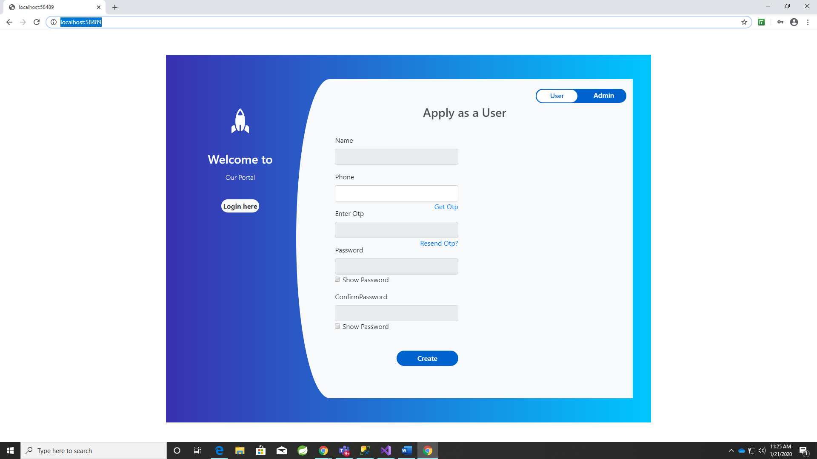

1. After OTP Send Other field get Enabled

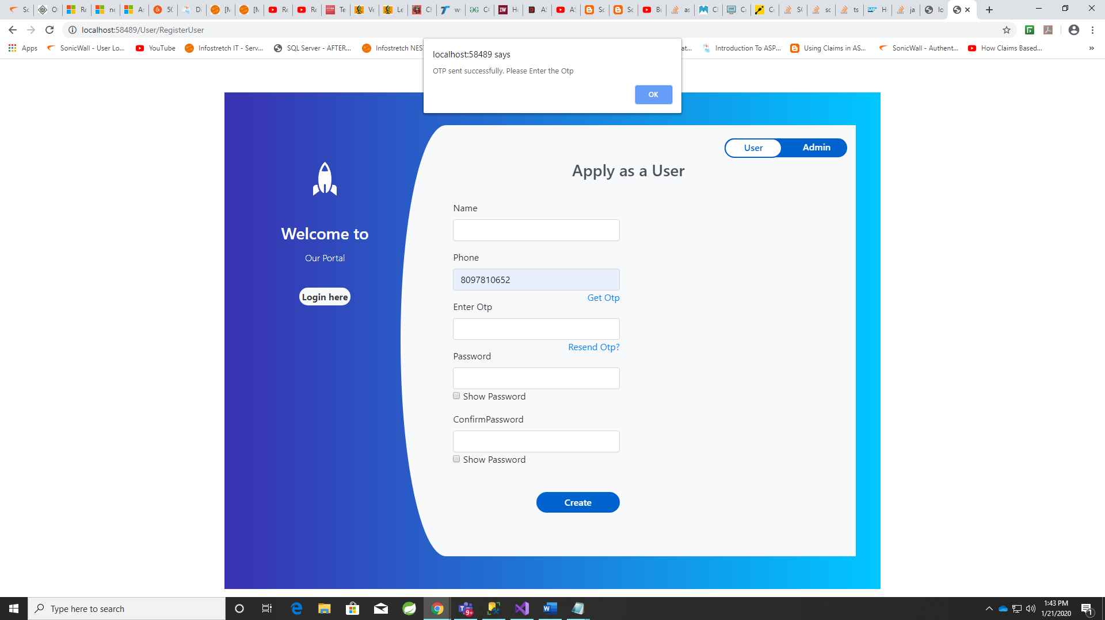

1. Login Page

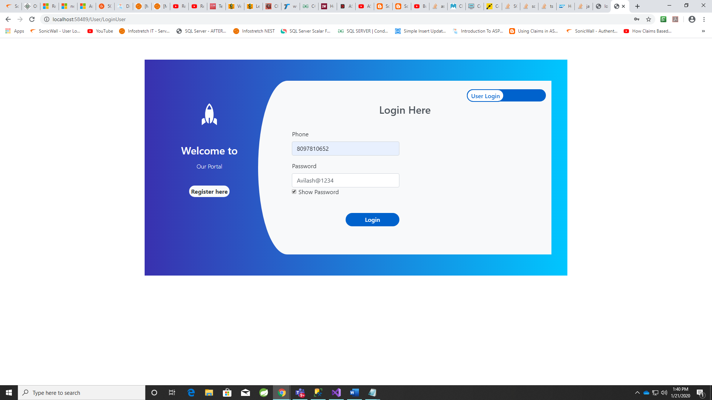

1. Admin Page

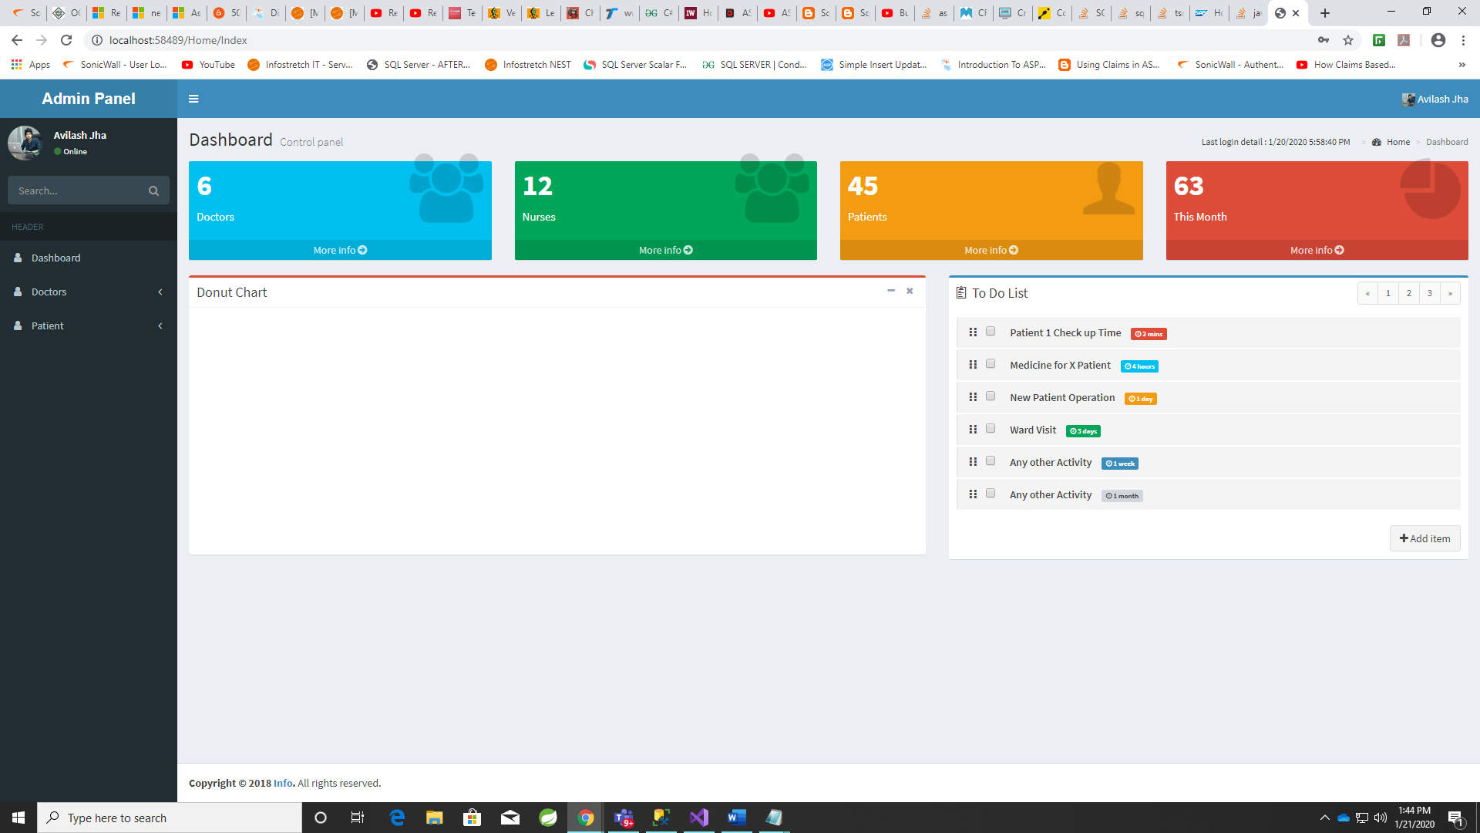

1. Add Doctor Page

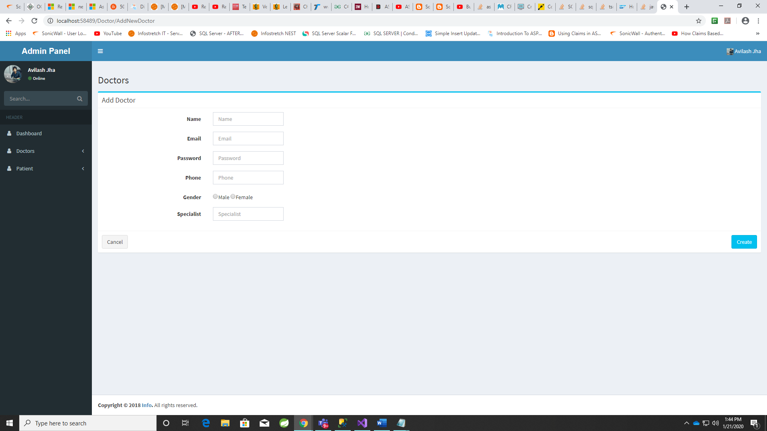

1. Add Patient Page

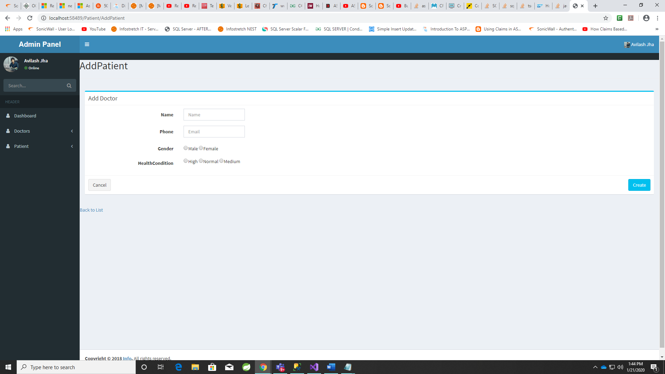

1. List Of Doctor Page

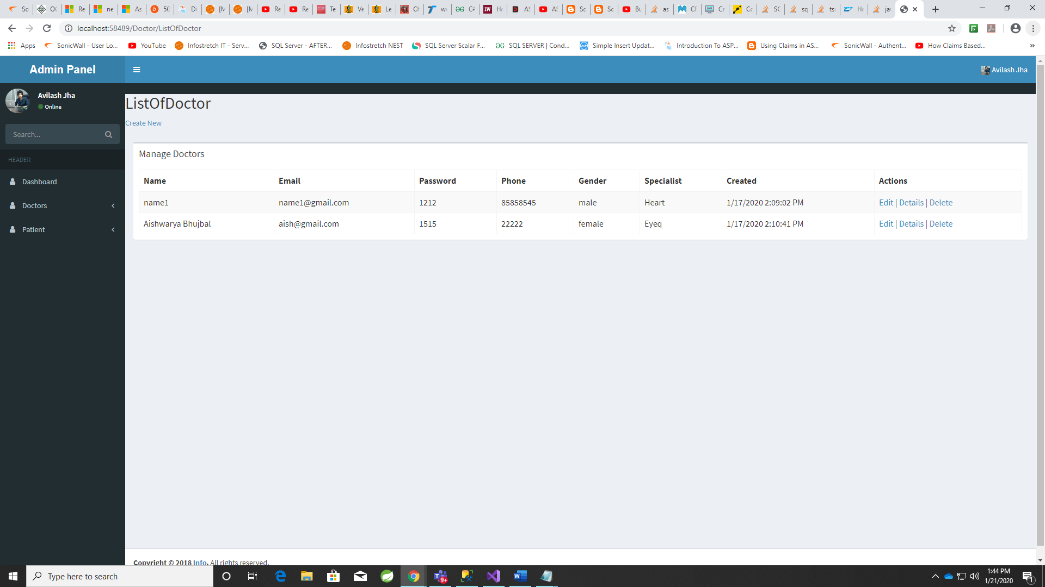

1. List Of Patient Page

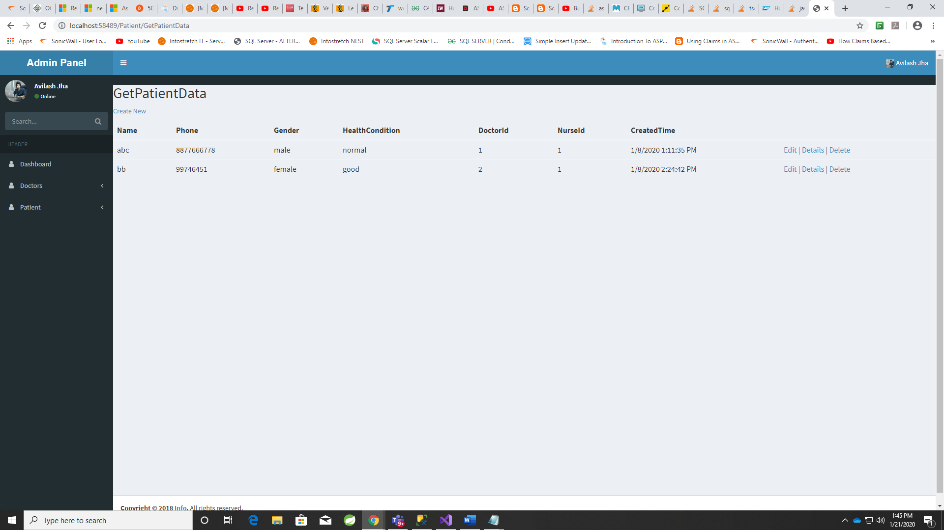

1. Edit Patient page. The field phone, Id, NurseId..etc are disabled

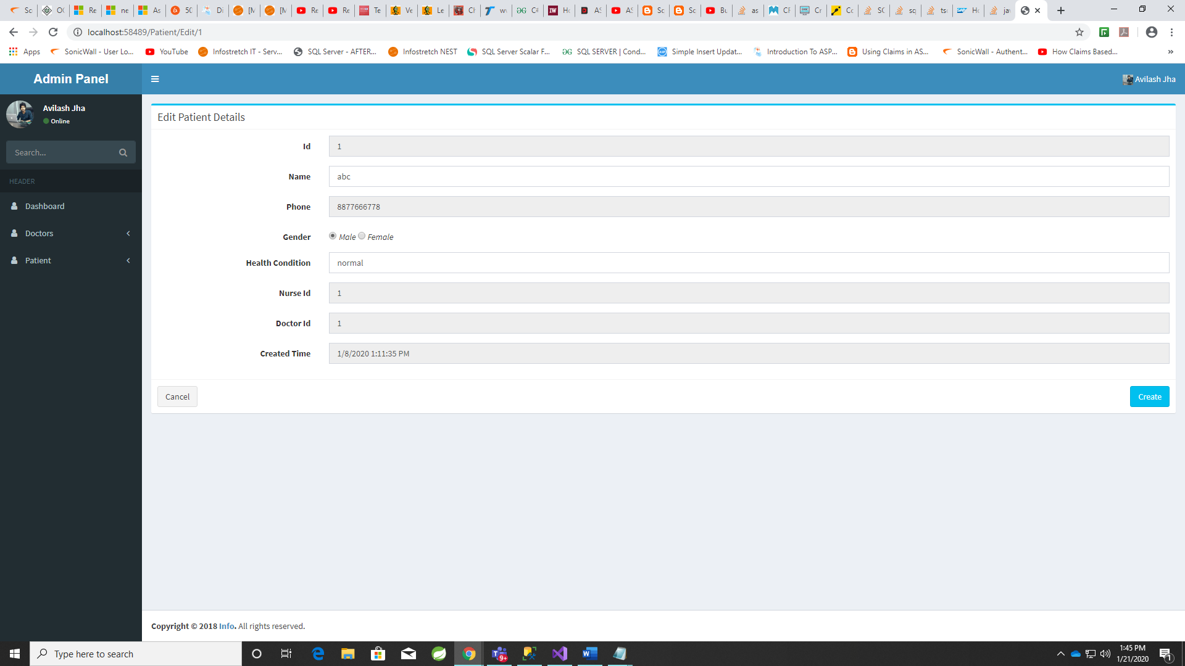

1. Edit Doctor Page.

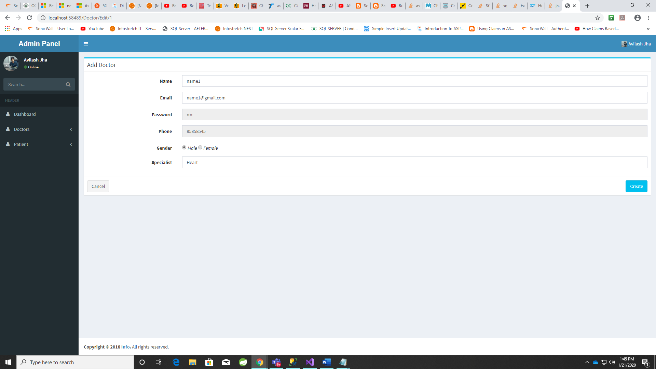

1. Get Doctor Detail By Id

